**IE 260 CLASS EXERCISES - WEEK 4**

1. Prepare a composite (weighted) index for housing construction costs in 2014, using the following data:

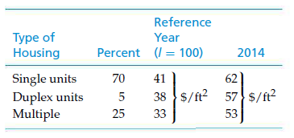

1. Six years ago, an 80-kW diesel electric set cost $150,000. The cost index for this class of equipment six years ago was 180 and is now 196. The cost-capacity factor is 0.7.
   1. The plant engineering staff is considering a 100-kW unit of the same general design to power a small isolated plant. Assume we want to add a precompressor, which (when isolated and estimated separately) currently costs $25,000. Determine the total cost of the 100-kW unit.
   2. Estimate the cost of a 50-kW unit of the same general design. Include the cost of the $25,000 precompressor.
2. The structural engineering design section within the engineering department of a regional electrical utility corporation has developed several standard designs for a group of similar transmission line towers. The detailed design for each tower is based on one of the standard designs. A transmission line project involving 50 towers has been approved. The estimated number of engineering hours needed to accomplish the first detailed tower design is 126. Assuming a 95% learning curve,
   1. What is your estimate of the number of engineering hours needed to design the eighth tower and to design the last tower in the project?
   2. What is your estimate of the cumulative average hours required for the first five designs?